Dashboard PCB Design Project

Project Team: Nate Coirier (Lead)

Fall Quarter - Winter Quarter

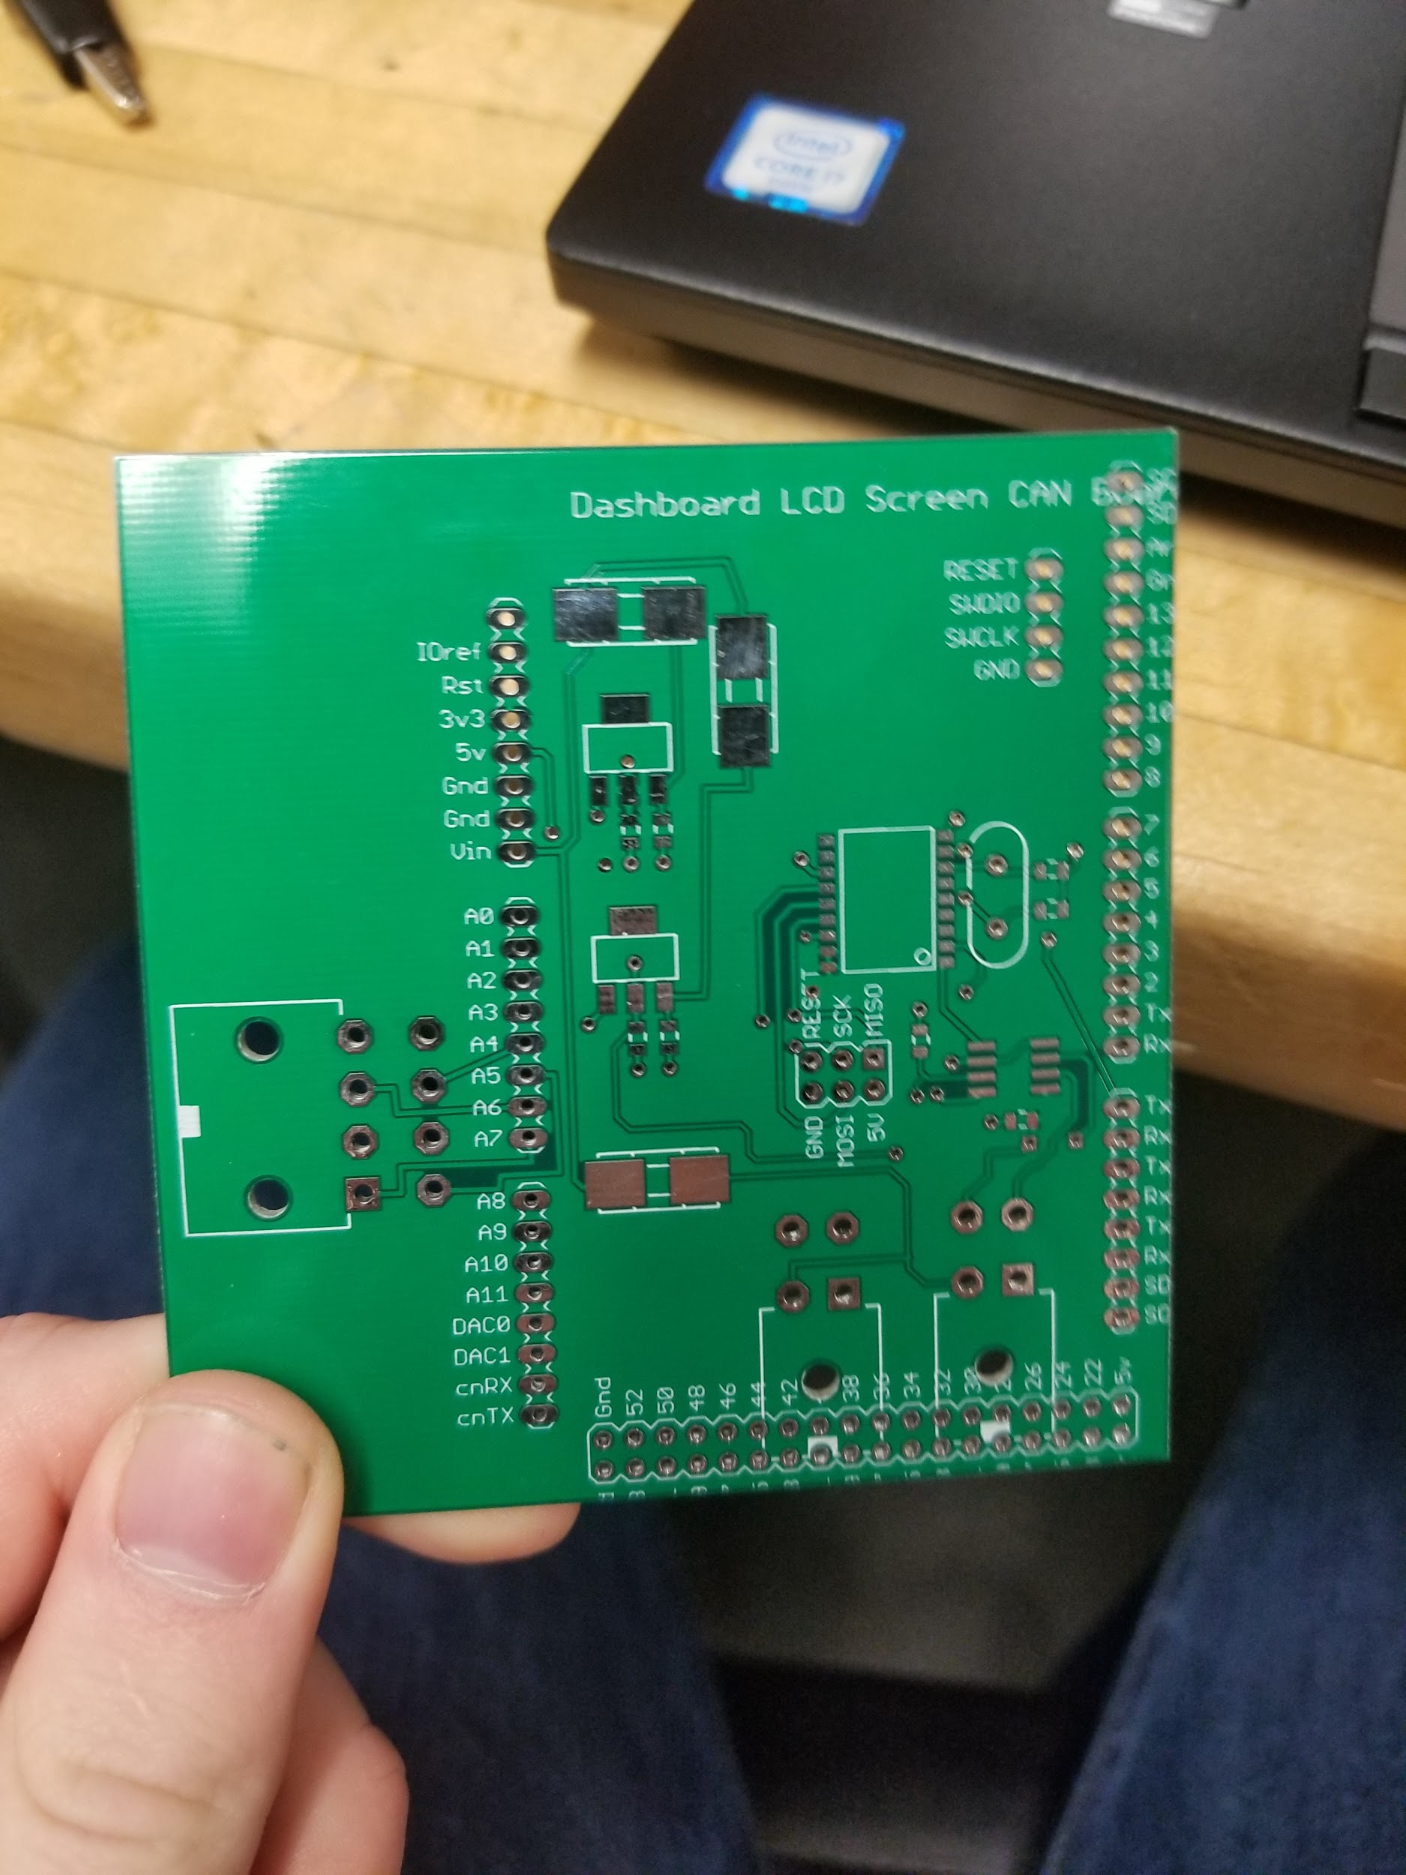

Contents:

Project Goal:

Overview of Project:

Current Status:

Project Timeline:

Components/Tools Needed for Project:

Hardware Components:

Software Components:

Special Tools Needed:

Design Process/Decisions:

Related Projects:

Regulations:

Record of Emails with Major Parts Supplier:

Other Notes:

# Project Goal:

Design and assemble the middle PCB in the dashboard arduino’s stack

## Overview of Project:

Create a board that can get signals from Charlie’s light board, the rest of the CAN network, send data to the rest of the CAN network, and also display retrieved information on the LCD screen on the dashboard.

Requires cooperation with the group programming the dashboard displays so that they know how to electrically use the “hat”.

## Current Status:

Board rev 1.0 is created. We are:

* Awaiting time to discuss how message passing will work with Charlie and the LCD Screen programmers, who are in a separate group from this hardware project
* After this discussion, more board revs/ additional requested features will be added
* Whenever the final revision of the board is decided, we will need to assemble the backups

## Project Timeline:

[A realistic timeline starting with where your project is right now, and what it will take to get to your project goal. We will adhere to these pretty tightly and print them off, so please make sure

[Try to do this by Thursday, Jan 25th]

If a task will take longer than 3 hours (a worksession), try to break it down into sub-tasks that take less time.

|  |  |  |  |
| --- | --- | --- | --- |
| # | Task | # of Hours | Person(s) responsible |
| 1 | Work with Charlie to make sure data is received properly | 1.5 | Nate, Charlie? |
| 2 | Work with LCD team to take care of pinouts and determine additional features necessary | 2 | Nate, Programmers |
| 3 | Test Board’s CAN functionality | 1 | Nate, Programmers, CANBus |
| 4 | Revise any Board Errors and Add additional accessible pins if necessary | 3 | Nate |
| 5 | Submit Revision Board + necessary pieces to Trello | 1 | Nate |
| 6 | Acquire parts/ boards for replacements and backups | 1 | Nate |
| 7 | Assemble backups | 3 | Nate |
| 40 | Test backups | 1 | Software Group |

## Components/Tools Needed for Project:

### Hardware Components:

|  |  |  |  |
| --- | --- | --- | --- |
| Component (and purpose, if unclear) | Number in Stock | Specific Location | Anticipated Cost (if team doesn’t currently have) |
| Circuit Boards | 5 | Green Bin |  |
| .1 uF caps | enough? | binder |  |
| 16 MHz 18 pF crystal oscillators | ~10 | Board Population Organizer |  |
| 22 pF caps | enough? | binder |  |
| Fuse / fuse blocks | 8 | Fuse organizer |  |
| 8 pin molex | ~10 | Molex box |  |
| 4 pin molex | ~10 | Molex box |  |
| MCP2515 | 8 | Board population |  |
| MCP2562 | 8 | Board population |  |
| NCP1117 Fets | ~5 | Board population |  |
| Stackable headers | ~5 | In box with rev 1.0 LCD board |  |

### Software Components:

|  |  |  |  |
| --- | --- | --- | --- |
| File Name | Description | Link | Well-Documented? |
| Arduino dashboard code | Drives the screen, reads CAN and light control board data |  |  |
|  |  |  |  |
|  |  |  |  |
|  |  |  |  |

### Special Tools Needed:

SMD soldering tools

* Heat gun
* Solder paste
* tweezers

## Design Process/Decisions:

* When I started, the board mostly looked like the pre-existing driver control board, except missing some of the sensor pins
* I added in the connectors to make it interface with Charlie’s board and also changed some of the pinouts because the LCD screen driver board on top had some conflicts electrically with how it was initially wired
* Connector to interface with Charlie’s board was much too large to be in the traditional footprint, so I tacked on a “sidecar” that’s pretty ugly
* It is important to be careful in adding the headers to the board and when stacking the boards together, as it can be extremely difficult and very easy to damage pins

## Related Projects:

* LCD screen code
* CAN data reception/ transmission
* Light Control Board

## Regulations:

What rules relate to your project? Check out the race regulations here:

<http://americansolarchallenge.org/regulations/ascfsgp-2018-regs/>

## Record of Emails with Major Parts Supplier:

## Other Notes:

More pins are on the board than technically needed, so it is possible to make more electrical connections accessible on the weird sidecar part of the board if necessary

Already completed is ____. Link to that is ____.